http://www.secondchancegarage.com/public/186.cfm Transcribed 2/22/14 by Drb

HOW TO USE AND INTERPRET A VACUUM GAUGE

Few tools or test devices are more useful and versatile than a vacuum gauge, yet very few hobbyists own one. A vacuum gauge can tell as much about the internal and external workings of an engine as the combination of a voltmeter, compression gauge, stethoscope and timing light.

An engine's vacuum readings can tell an awful lot about its running parameters, provided you know how to read the gauge in the first place. Unfortunately, most vacuum gauge manufacturers don't provide easy-to-follow instructions and diagrams to help users interpret gauge readings, rendering the gauges themselves virtually useless. We're here to change all that, so follow along with us on a tour of vacuum gauge readings and we'll show you all the neat things you can do with one.

A Tiny Bit of Technical Stuff

Atmospheric pressure is measured at 14.7 pounds/square inch at sea level. That pressure corresponds to the weight of air holding a column of mercury 29.92 inches in height. Vacuum is by definition: pressure below normal atmospheric, commonly caused by a suction that is taking the air molecules away from a particular location. In engines, of course, the air is being sucked in by the vacuum created by the movement of the pistons.

The Gauge Face

All vacuum gauge faces are graduated in inches of mercury, although some have additional scales in millimeters of mercury. For those interested in international equivalents, one millimeter of mercury = one Torr. Further, one atmosphere = 760 torr = 1.013 x 105 Pa (Pascal).

Note also that most vacuum gauges are equipped with an additional scale that measures fuel pump pressure. This allows the user to connect the hose directly to the fuel line entering the carburetor to measure the fuel pump's pressure. Since many fuel system problems can be traced to the pumps themselves, such a tool can save a lot of troubleshooting time. Is this a great tool, or what?

Hook It Up!
The most important thing to do when using a vacuum gauge is to connect it to a constant vacuum source on the engine. Some manifolds incorporate a plug that may be removed for such purposes. If none exists, the next best place to connect is the PCV hose. If that's too hard to reach, connect to the power brake vacuum hose (on the engine side of the one-way valve in the hose).

Lastly, you can connect to the vacuum line at the carburetor, but make sure the line has vacuum at idle. Many distributors were designed to get advance vacuum only when the throttle plate was opened, in which case there was no vacuum at idle. Make sure you've connected things properly.

The Readings

Note: The readings following will be typical at sea level. In general, subtract one inch for each 1000 feet above sea level. Also, these readings are typical examples seen in stock engines (except where noted,) not absolute "drop-dead" numbers for your engine! The idea here is to use the vacuum gauge to see how far your engine is differing from normally expected readings. Your gauge's needle might move at slightly different rates, so don't be concerned. You need only recognize a "flicker" from a "sweep."

The readings in Scenario 1, 2 and 3 below are normal readings taken from a properly functioning engine. The remaining Scenarios represent engines with various problems, as explained in each Scenario.

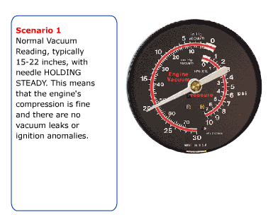
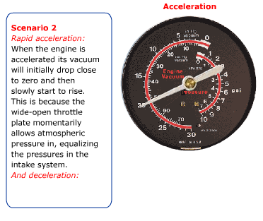

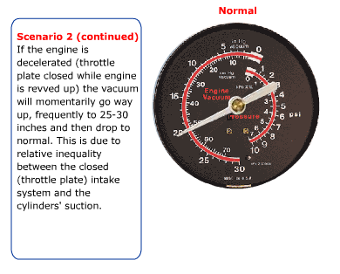

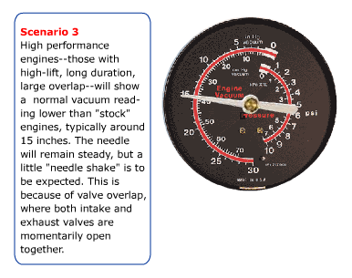
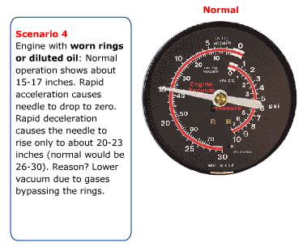
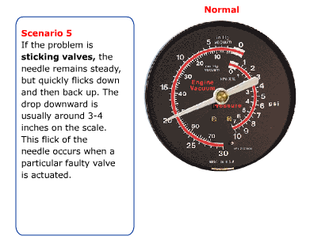

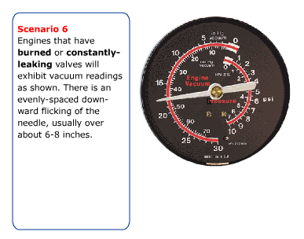
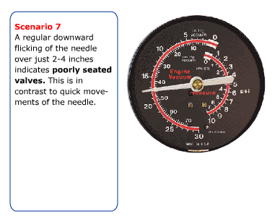
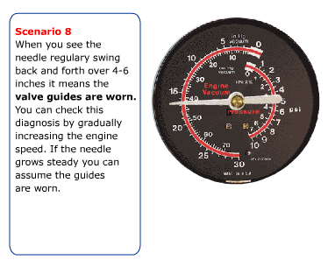

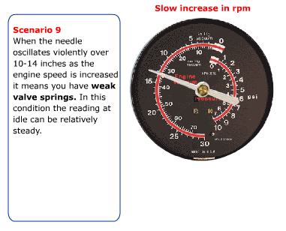

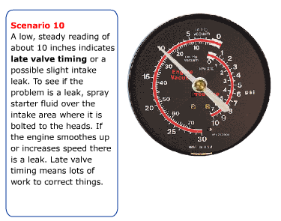

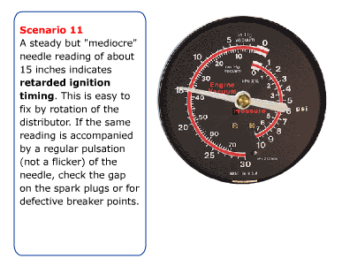
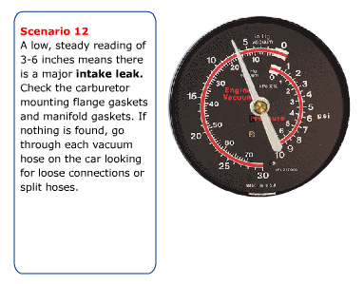

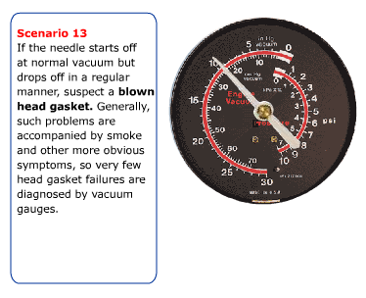

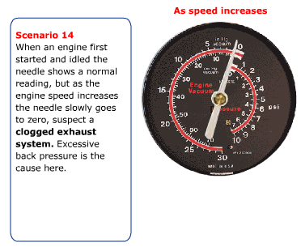
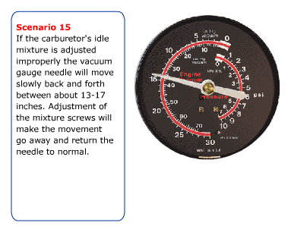
Conclusion

We hope you've enjoyed our little tour through the uses and meanings of vacuum readings. When you get accustomed to using yours we are confident you too will sing the praises of the lowly, underappreciated vacuum gauge.

